Assignment for Module 2 (Web Pivot table)
The Module 2 assignment provides experience with WebPivotTable, an open source application for business intelligence. Using WebPivotTable, you will customize a pivot table and extend it to show more aggregated fields. WebPivotTable is a pure Javascript application that can be used in any browser and needs no additional plugins.
Before starting this assignment, you should read the Web pivot table tutorial. The tutorial demonstrates the usage of WebPivotTable and the OLAP cube source to be used for this assignment. It also demonstrates MDX to specify a pivot table. If you have not read the tutorial yet, please refer to it prior to starting this assignment.

Load the Data Cube
- Select the preloaded OLAP cube Microsoft Adventure Works (same cube used in tutorial) from the Demo list to create the pivot table.
- Take some time exploring the data cube before beginning on the details of the assignment.

Create the Pivot Table
Create a customized pivot table that shows the following:
    - Expand the “Product” dimension in the Fields List.
    - Select “Product Categories” in the rows area.
    - Expand the “Date” dimension in the Fields List.
    - Select “Date.Month of Year” in the columns area.
    - Expand the Measures in the Fields List.
    - Select “Average Sales Amount” in the values area
    - Take a screen snapshot and paste it into a document as the snapshot for part 2 of the WebPivotTable assignment. The snapshot should show the All Product Categories with complete expansion showing of a subset of values for the rows and columns.
    - Keep the sheet open for the next part.
    - Separately, you should answer quiz questions 1-5. You will see a separate grading item for the quiz associated with the Web pivot table assignment. The peer review is a separate grading item for the Web pivot table assignment.

Extend the Pivot Table
  - Collapse rows so that only the four (top level) categories (Accessories, Bikes, Clothing, and Components) appear in the rows area. You will need to select the – buttons to collapse each category. Scroll so that December appears on the far right corner of the table.
  - Add the “Class” item in the Product dimension to the rows area. Make sure it is displayed below the “Product Categories” in the Pivot table. Collapse the Product Categories dimension in the rows to show only the top level categories if expanding after adding the Class dimension.
  - Add the “Source Currency” level. Do NOT include “ALL” level from the Source Currency dimension to the Filter field.
  - Create a filter such that the pivot table displays values only for “Canadian Dollar” and “US Dollar”.
  - Take a screen snapshot and paste it into a document as the snapshot for part 3 of the WebPivotTable assignment. The snapshot should show the January Average Sales Amount for All Products along with a subset of the expansion for Product Categories and Month of Year specified in other parts of part 3.
  - Keep the sheet open for the next part.
  - Separately, you should answer quiz questions 5 to 10.

Extend the Pivot Table with Additional Filters
- Modify the filter to show results only for the source Currency “EURO”.
- Add a filter on Date.Calendar Year. The filter should only display CY 2004 sales.
- Collapse all product categories except for Bikes. Show only the subcategories within the Bikes category.
- Collapse the Class member values for all categories expect for Road Bikes.
- Remove the pivot chart so that the sheet only displays the pivot table.
- Take a screen snapshot and paste it into a document as the snapshot for part 4 of the WebPivotTable assignment. The snapshot should show the January Average Sales Amount for All Products along with a subset of the expansion for Product Categories and Month of Year specified in other parts of part 4.
- Separately, you should answer quiz questions 11 to 13.

Grading
Two parts will assess your performance: a quiz and a peer review. The quiz is designed to test your understanding of the assignment requirements. The peer review will ask you to submit screen snapshots for parts 2 to 4. You will receive 50% if you provide three files (one for each part) in the peer review section. The other 50% will be determined by your response to the assignment quiz.

Submission
You need to answer the quiz questions for the module 2 assignment. You also need to submit the saved screen snapshots from parts 2 and 4 to the peer review for the module 2 assignment.
Solution: first snapshot (Areas, pivot chart, Rows with expansion of product categories) for part 2
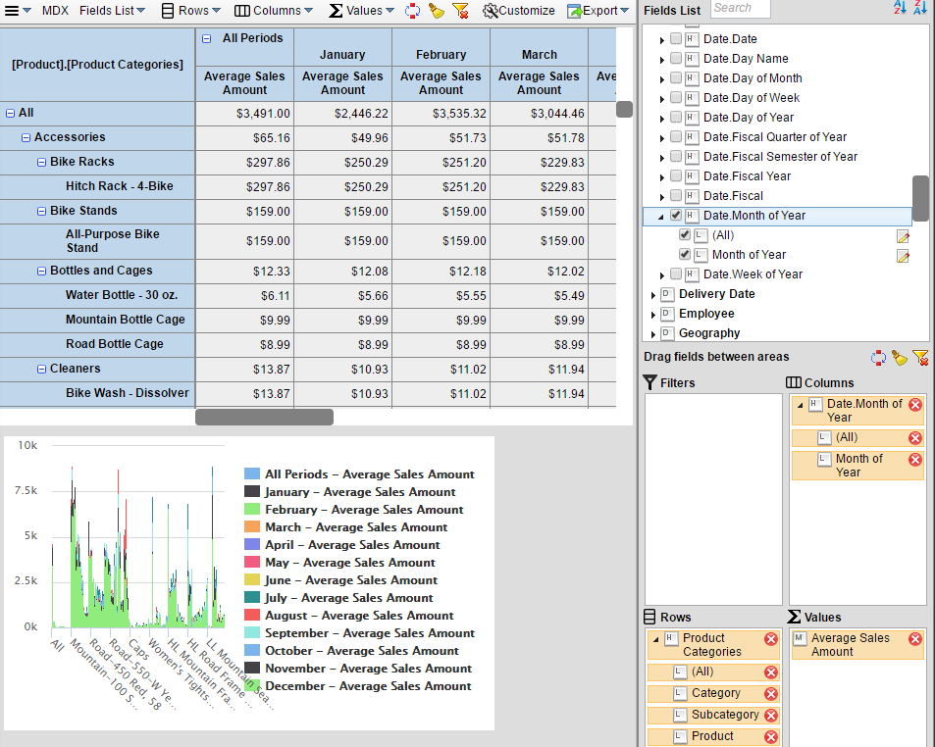

Solution: second snapshot (Source Currency filter field, collapse of subcategories) for part 3
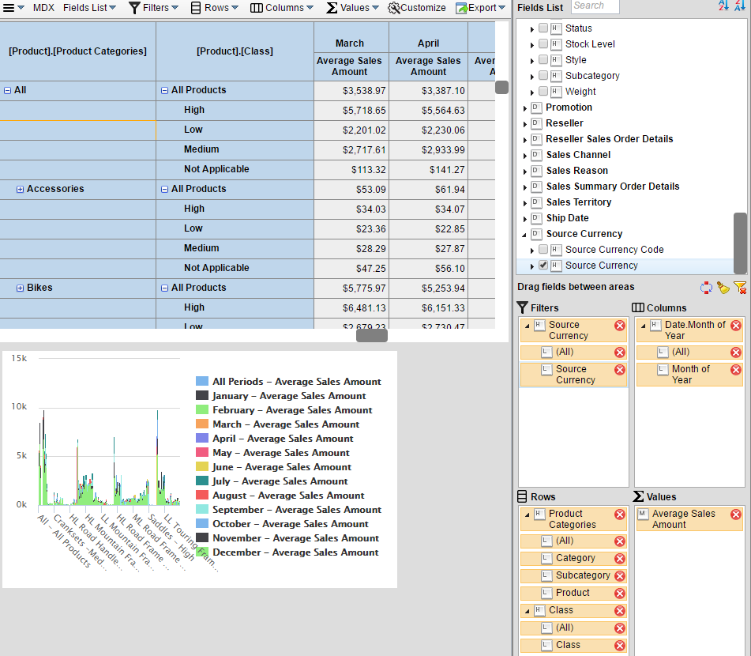

Solution: third snapshot (no pivot table, collapse of class and categories except for Bikes, Calendar Year field in filter area) for part 4
